

AUSTREY FLOWER, PRODUCE & CRAFT SHOW
Sat 10th Sep 2022 Austrey Village Hall, Main Road
The Show is FREE TO ENTER & open to everyone of all ages wherever you may live. Just bring your entries on the day. There are 45 classes & only one entry per person per class.


VEGETABLES AND FRUIT (Kirtland Cup)
If you
Grow it…….
Show it !

- 3 onions (dressed, any size)
- 3 onions (as grown, with roots washed)
- 6 shallots
- 3 beetroot (tops trimmed to 7.5cms/3 inches)
- 3 leeks (roots washed and trimmed)
- 3 carrots (tops trimmed to 7.5cms/3 inches)
- 6 runner beans
- 6 French beans
- 3 courgettes (max length 15cm/6 inches)
- 3 potatoes (all of one variety)
- 1 cucumber
- 6 medium or large tomatoes (with calyces/stalks attached)
- 6 small tomatoes (with calyces/stalks attached)
- A specimen vegetable not already named (3 small/2 medium/1 large)

- Any misshapen vegetable
- A collection of a flower, a vegetable and a fruit
- 3 apples with stalks, cooking or dessert
- 10 blackberries or 10 raspberries all with stalks displayed on a small plate

FLOWERS AND HERBS (AGS Vase)
- A vase of mixed garden flowers (not an arrangement)
- The best perfumed rose – one stem (trophy : Margaret Murr Rose Bowl)
- 3 dahlias
- 3 stems from a flowering shrub
- 1 specimen bloom (not a rose)
- A small bunch of 4 different culinary herbs
- A plant in a pot (maximum pot size 20cm/8 inches in diameter)

HOME-MADE PRODUCE (Rose Bowl)
- A jar of fruit jam (labelled and dated)
- A jar of fruit or savoury jelly (labelled and dated)
- A jar of chutney (labelled and dated)
- A bottle of home-made wine
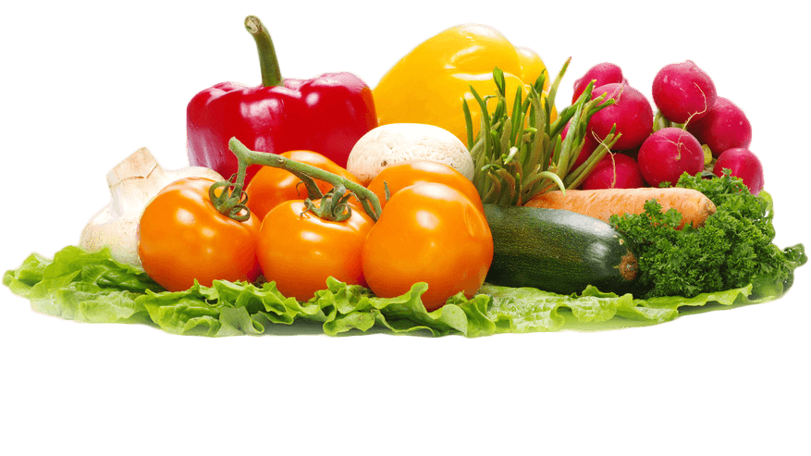
The following classes should be exhibited on a plate and covered. If using cling film a cardboard collar will raise the cling film above any icing.
- Victoria sponge (3 egg size. Jam filling only. Caster sugar sprinkled on top)
- Chocolate sandwich cake (use the ‘All in one’ recipe printed below)
- Any vegetable cake (e.g. beetroot, carrot, courgette etc)
- 5 fruit scones
- 6 cheese straws

PHOTOGRAPHY
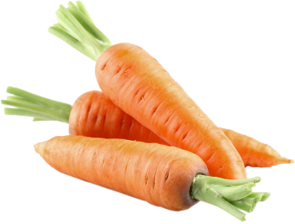
- A digital photo of a single flower, emailed as an attachment to austreygardeningsociety@gmail.com (to be displayed via computer at the show). Closing date for entries is midnight on 7th September 2022

CRAFTS (Paul Bennett Shield)
(Maximum space allowed for each exhibit is 30cm x 30cm/12 inches x 12 inches)
- Something new from something old
- An item crafted from paper or card

- Any other home-made craft item

Competitions for CHILDREN only (Children’s Cup)
- A jam jar of mixed garden flowers
- An animal made from vegetables and/or fruit
- A collage made from recycled materials (maximum size A4)
- 16 different items in a small matchbox, with a list of the items
- A garden in a seed tray or similar sized container
- An A4 sized poster – subject ‘Save the Planet’
- The longest runner bean

* * * * * * * * * * * * * * * * * * * * * * * * * * * * * * * * * * * * * * * * * * * * * * * * * * * * * *

Recipe for the CHOCOLATE SANDWICH CAKE - Class 31
INGREDIENTS: 2 tablespoons cocoa 3 tablespoons boiling water 8 oz. (225 g) soft margarine 8 oz. (225g) caster sugar 4 eggs 8oz. (225 g) self-raising flour 2 teaspoons baking powder
FOR THE FILLING AND TOPPING: 2 oz. (50g) soft margarine 6 oz. (175g) icing sugar, sifted 1 tablespoon milk Coarsely grated chocolate to decorate
Two 8 in (20cm.) sandwich cake tins, lined with greased greaseproof paper
Pre-heat the oven to 180ºC/350ºF/160ºC Fan/Gas 4
Blend the cocoa and water in a mixing bowl then leave to cool slightly. Measure all the remaining ingredients into the bowl and beat well until thoroughly blended. Divide the mixture evenly between the tins and level out.
Bake in the pre-heated oven for about 25 minutes or until well risen and the tops of the cakes spring back when lightly pressed with a finger. Leave to cool in the tins for a few moments then turn out, peel off the paper and finish cooling on a wire rack. To make the butter cream, blend together the margarine, icing sugar and milk until smooth, use half of the butter cream to sandwich the cakes together. Spread the remaining butter cream on top and decorate with the grated chocolate
NB Every oven is different so you may need to adjust temperatures and timings slightly to suit yours

* * * * * * * * * * * * * * * * * * * * * * * * * * * * * * * * * * * * * * * * * * * * * * * * * * * * * *
Staging of entries 9.30am – 11.30am
Judging 11.35am – 2.30pm
Viewing open to the public at 2.45pm approx: (free entry)
Prizes awarded & raffle drawn at 3.30pm approximately after which (and not until) all Show entries must be removed from the Village Hall
If you have any questions (or need help understanding the categories), please do get in touch with Colin on 07974 924 195 or austreygardeningsociety@gmail.com
Austrey Flower, Produce and Craft Show is organised by the Austrey Gardening Society (AGS)

Also, if you are interested in gardening, please do come along to one of our monthly garden club meetings, we are friendly enthusiastic bunch and you would be very welcome, especially beginners. If you would like to participate from home, we are affiliated with the Tender Shoots Garden Club Network and all our members have free access to the online zoom talks. Please check the program of talks on the www.tendershoots.uk website. Guests are also welcome. The zoom login details are: Zoom Meeting ID = 404 301 4750 Passcode = bonsai
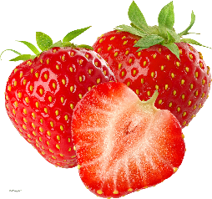
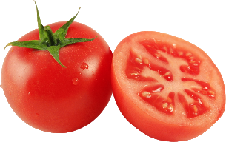
Happy Gardening

